The Colonial Climate:
Infrastructure, Nature, and the Making of the World’s Finest Climate
June 14-15, 2024
PART 1: SUB DIEGO
This talk begins in San Diego. It begins in the wake of a catastrophic earthquake. That earthquake occurs in issue 15 of the DC comic series Aquaman – and it is the catalyst for an improbably large tidal wave -- called the American Tidal -- that floods and drowns half of the seventh largest city in the country – permanently submerging much of downtown San Diego.
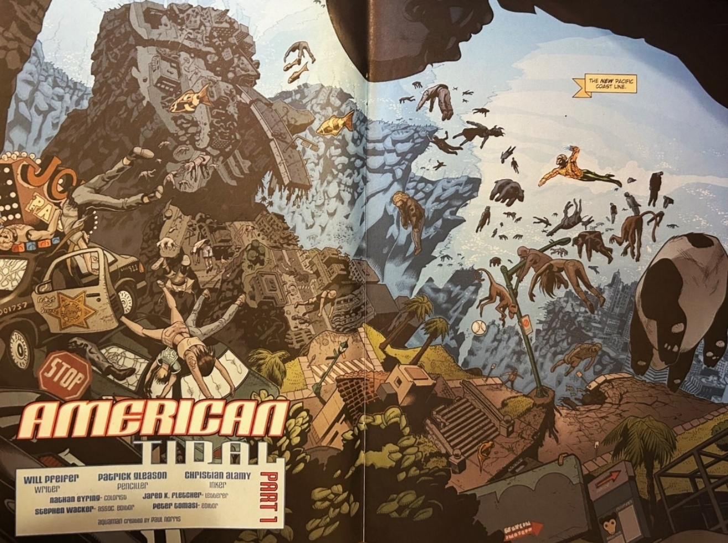
With the city’ prime real estate now underwater, not unlike the fabled city of Atlantis, San Diego gets redubbed with a certain comic playfulness Sub Diego, or submerged San Diego. This is the plotline for this comic book series that ran for a dozen issues in 2004 and then again for a redux a decade later.
The fictional sinking of San Diego from sea level rise has, of course, an obvious context. It occurs against the backdrop of the contemporary fear of climate change and the collective fear that nature is angry with us and is now rearing its head up its head in response to a century of profligate human activities that people in this room have called variously fossil capitalism, the Anthropocene, the Great Acceleration, the Capitalocene, the Great Divergence, and so on. The image of environmental collapse presented here is part of the broader cultural response to climate change we are all familiar with, in line with disaster literature and disaster cinema that makes it onto our TV screens, into our studios, and through osmosis into nonfictional reporting at the daily news hour. It is the apocalyptic gesture of the genre that people call CliFi.
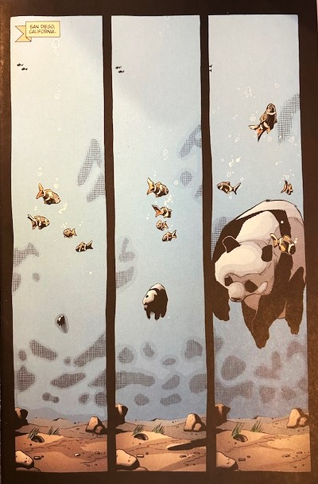
Fitting to the graphic novel, this apocalypse has a certain heightened spectacle to it: with the city’s iconic imported Giant Pandas bloated and floating on the sea, its monkeys from the local zoo hanging in midwater, its high-rise buildings that make up some of the most expensive real estate in the US relative to income submerged underwater, and its human population set adrift like dead detritus in the shape of some creepy aquatic mobile.
I will get down to some serious business shortly. But in some very real sense, this talk traces back to this strange DC comic book series, to this surfer bro super hero that looks just like every stereotyped marketing poster of this city’s history, of blonde men and women at leisure in San Diego, and to an uncanny concatenation of events surrounding my personal encounter with this comic strip.

I read this comic series first back in the summer of 2020 just as a global pandemic was turning an already wickedly hot summer in what is marketed as the world’s finest climate into the twin calamity of nature attacking from the inside and the outside. The day was a wildly hot one in July or August. I can’t remember. The thermometer had climbed to 94 degrees Fahrenheit if you’re a patriot, to 34.5 degrees Celsius if you are not. And it was a muggy heat – all of which had a certain novelty to it that reeked of climate change. After all, San Diegans have had one of the shortest thermometers in the world, hovering at pretty ideal levels for human comfort. We didn’t used to need air-conditioning 50, 60, 100 years, ago in the city. But that was a different climate. And so on that day I like many other people was waiting out these uncomfortably rising temperatures, sweating on my orange Ikea couch, waiting for the real climate, as I thought, to come back, to return, while trying to make sense of how this heat wave jibed with the reputation San Diego had crafted for itself in the 1880s when local meteorologists teamed up with the Chamber of Commerce to brand the city as the world’s finest climate.
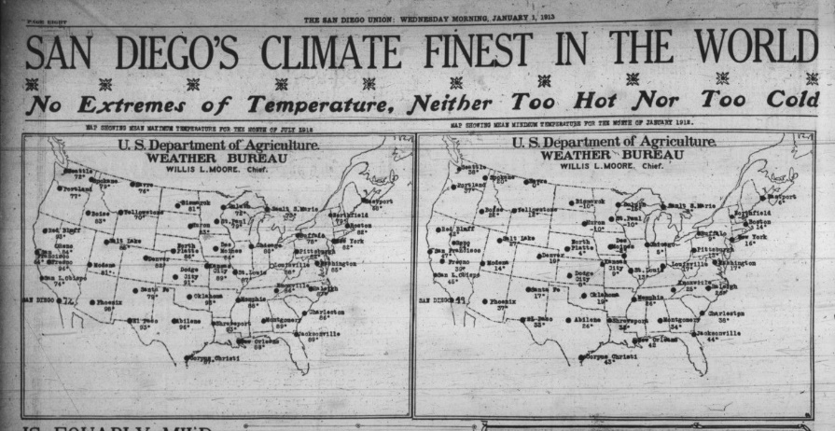
But that was not all. In addition to heat, drifting in from the mountains was ash and smoke from human-induced wildfires, smothering us a bit, a climate-induced phenomenon that is slated to increase each year in California. Heaped on top of this was the sonic boom that comes from living under the flight path of this climate destination that draws 32 million tourists a year in pursuit of the seemingly perfect sun they have been sold on. 620 departures and landings a day. Delta, British Airways, United, Southwest, Alaska, Lufthansa – another passenger plane every five minutes racing over my head, literally, because the planes land perilously close to my and my daughter’s bedrooms if you want to be in the thick of the city. (I once told her, when she was gullible, that you could catch a plane if you had a fishing rod. And if you had rollerblades, you could ride it for a spell.)
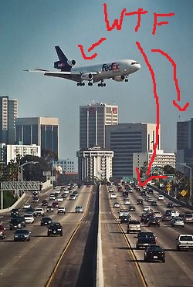
This from the article “San Diego has a Small, Weird Airport and It’s Kind of Freaking Me Out.”
So too, because we live downtown, were the sights and sounds of industrialized infrastructure – the theme of this conference – garbage trucks with metallic screeches whisking away the refuse of 3.3 million people now and construction trucks generating the constant drone that goes with maintaining this colonial legacy space that we (who is this we?) have built here. The unwanted sound of everything we want.
So here was a strange confluence of events – jet-fueled airplanes and petrol-fueled garbage trucks (transportation, you will remember, makes up 28% of US greenhouse gas emissions), an oil-induced heatwave (San Diego’s temperatures are rising annually due to climate change with new extremes becoming the norm and air-conditioners going up everywhere), human-induced wildfires and ash raining with little flakes of tree ash able to be caught in one’s hand (the wildfire season is now a month longer due to climate-induced droughts and we sometimes look in the sky for the Horseman of the Apocalypse), and then there was this graphic comic series with San Diego drowning in an imagined future in which nature has overturned the social order that Anglo colonists built here between 1846 and today after they dispossessed Kumeyaay Indian tribes and relegated to the region’s Hispanic population to secondary citizenship (at least for some time).
This was, in short, an intimate personal encounter with climate change at the local level: first, as an embodied experience, as I sat there in sweat and discomfort, breathing in smoke and wondering what in the world was going on, and second as an imagined, fictionalized experience reading about the future we all worry about, steeped in the figurative drowning of San Diego, and the advent of Sub Diego, what Bill McKibben calls Earth 2.0.
So you might understand me when I say I was a little bit haunted by the following line I read in this comic. It is delivered by this blonde and blue-eyed hunk of a surfer superhero who stares straight into the reader’s eyes and announces to all of us survivors that home is no longer available to us:
“You can,” Aquaman says, “NEVER go HOME.”
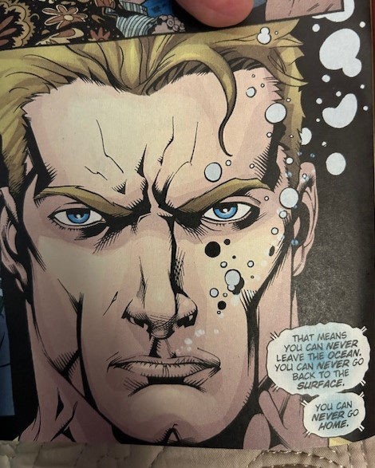
None of us can really go home now.
So that made me think about a few things. What is home? What is this particular home that was built in San Diego, how was it made, who made it, who was and is attached to it, and what role have nature and culture played? Or put a bit differently: if this is, as I argue, a colonial home – a certain colonial relationship to nature – then what might a post-colonial home be as we inhabit this changing climate?
That got me started on this new book which I’ve entitled The Colonial Climate: How We Made and Unmade the World’s Finest Climate, 1846-Present.
I won’t disappoint you: I will return to Aquaman at the end of this talk. After all, you might be curious that in this apocalyptic future Sub Diegans undergo genetic modification to replace their lungs with gills so they can breathe underwater – even if they can never go home to dry land. But my point here is simply that this story of San Diego – and this allegory of climate change in this comic book series – might be relevant to your lives in the UK and elsewhere. I want to put it forward as a metonym, a metaphor, some figurative thing of the like – in our fight against global warming. After all, saving the world’s finest climate, as it were, might not have some symbolic value like saving the polar bears or the glaciers of Glacier National Park. 7:30 minute
PART 2: THE GAME PLAN
So let me explain the game plan here.
Rather than deal in the titular topic of this conference head on, that is, infrastructure and the energy humanities, I want to focus on what I think is the antecedent to this conference, the thing that drives all this bluster about energy infrastructure, energy literature, energy history, and the like – that is, climate change, global warming,…
and a term I want to test out on you: “the colonial climate.”
As for me, I have spent about two decades staring at this barrel of oil that I have begun to suspect that not unlike staring into the sun during an eclipse I am having a bit of a hard time seeing what I want to see through this lens.
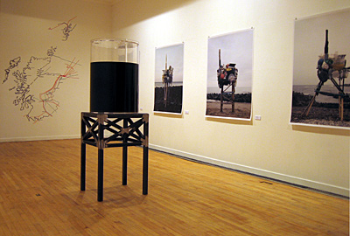
Ernst Logar
So I want to try out this concept of the colonial climate on you. I think it works quite well for my regional study of San Diego – but I’m wondering if it might be extrapolated more broadly, if it can travel beyond South California to the places you care about. This is a bit of a humble response to Donna Haraway’s claim that we need a “big new name” for the historical moment we are inhabiting – a term that can at once deal better with the history of our entanglement and nature while also speaking to the lived histories we inhabit. Global Warming doesn’t do it. Nor does Climate Change.
So, in the time that remains, I want to do three things:
First, I want to:
- Deconstruct the Terminology of Climate Change
I want to propose, and I’m not the first obviously, that the paradigm spun around this term climate change might actually be counterproductive. So I’ll take a few minutes to illustrate the liabilities of using this terminology for our purposes in the humanities and social sciences.
Second, I want to:
- Propose the Colonial Climate as an Alternative
The goal here is to lay out the theoretical and historical grounds for naming the period we inhabit – a period that is an interregnum in human history – the colonial climate. You’ll tell me, I hope, the extent to which it is useful, the extent to which it is hackneyed or derivative, and the extent to which it might have a little line in the reel worth unravelling.
And, third, I want to:
- Use San Diego as a Case Study in the Colonial Climate (9:00)
Give you a few examples from San Diego to show that help to concretize what I’m trying to argue here.
PART 3: WHY CLIMATE CHANGE IS NO GOOD
So, first, “why climate change is no good” for us.
The term originates in the natural sciences, perhaps as far back as in 1896 when the Swedish scientist Svante Arrhenius deduced that manmade greenhouse gases could theoretically heat up the planet. Since then, the term Climate Change has cycled through scientific papers on the Keeling Curve and a million other things to ultimately wend its way into the daily news cycle in the wake of the first IPCC Report in 1990.
Climate change is a pretty good term for certain scientific purposes. It is a good descriptor capturing the wild array of long-term changes in weather patterns that lead to drought stress in sub-Saharan Africa or polar vortices in the Northern Hemisphere that trace back to human-induced activity.
But Climate Change can’t do much more than that. It falls flat when we start to use it as a historical concept – to speak to the human nature interface. That is because climate change as terminology erases as much it renders visible. Read literally, climate change only tells us that, to be perfectly clear, the climate is changing – that the weather patterns are moving in some new direction. It doesn’t say much. And, unlike the term Global Warming, which signifies some type of planetary warming on average, climate change does not even weigh in on the direction of the climate changing. Consequently, it can’t point us to the big historical questions we need to answer concerning human affairs, the type of questions that people in this room have asked in a thousand different ways: From where does this change originate? What was the history that got us here? Even, God forbid, who might be responsible for this change?
But you know that, perhaps.
The alternative phrasing, Global Warming, is not much better. (11 minutes)
The term Global Warming only tells us that on some highly abstracted level that sits outside of people’s lived experience that the world’s temperature is angling upward on the average. Temperature averages are, however, meaningless outside of a handful of very useful contexts. Those contexts are not unimportant. For instance, averages are useful for helping climate researchers make historical comparisons among regional weather patterns over long periods of time that are otherwise not impressionable on the body, or sensible to the human. But, beyond that, global warming can’t capture what is experienced on the ground, what happens on the lived level, what sits in the temporality of the human. Nor can it capture the abundant swoon of nature that is so much more than abstracted data collection can portray. Here among the finite and the terrestrial, this slow upward trend that we call global warming is just one indicator of climate’s presence in our lives as both noumena and phenomena, that is, how climate touches our lives as matter and as experience, as thing and perception of things. On the lived level, global warming has a different shape and texture than the reports tell us. It does not look, feel, smell, or sound so unidirectional. In fact, it appears at the ground level to people and also in the scientific data we see in our statistical models to be as much chaos as it is warming.
Which of course it is.
But these have become the dominant terms in our public discourse, the current metanarrative for framing what is happening to us. The trouble is that they don’t travel well outside of the natural sciences. They are highly abstracted computational concepts that don’t touch on the affective and imaginative structures those of us in this room care about as we try to make sense of our world. They can’t really provide the pivot for writing what Van Wyck Brooks once called the usable past that we require or what Foucault might have said was the right genealogy for the moment.
So how much does this naming of the problem matter. What’s in a name? Is a rose by any other name yet a rose?
Those of us in this room all know the answer. Naming matters because it conditions how we see and report on the world. It sets the knowledge paradigm, shaping the problems we observe and the questions we ask. So is it really enough after all to say, as our news headlines and scientific reports do, that climate change, or global warming, is human induced? Are we really looking at a history written by humanity writ large? Or is it better, as those of us in this room know, to tell this story as a story about a particular set of human beings with a peculiar set of values, with peculiar institutional structures, and with peculiar ambitions and ignorances who changed the composition of the atmosphere and with it the climate? This was not the work of humanity at large. It was the work of some subset of humans, bound together by time and space, let us call them westerners or Global Northerners for lack of better names, who generated this warming that got us started on this path that we have lost control of – and that might not now be fully explainable any longer by reference to only western colonization.
It’s sort of weird that we have somehow inadvertently ceded as a profession the writing of this history to the natural sciences – with the notable exceptions of trying to rally our knowledge production around concepts like the Capitalocene, the Anthropocene, the Plantationcene, the Cthulucene, and what my colleague John McNeil has proposed the Great Acceleration, the Cthulucene. Might the Colonial Climate be something that can capture these under a nomenclature that lands more directly on the structures we are already familiar with and that speak to the narratives we already use? We are already well versed in and skilled in teaching colonialism – and so why not name this humanized climate after it? It has a certain simplicity to it – but does it come up short?
14 minutes
PART 4: WHY NOT THE COLONIAL CLIMATE?
I will define the term more concretely shortly. But first… let me address what I think is a reasonable objection to this provocation:
Was western colonization a necessary and sufficient condition for inducing climate change?
The answer to the first part of that question is an easy yes. Colonization was necessary. Climate change does not happen without the networks and pressures of colonization – its insistence on spreading its values, its markets, its technologies, and its modes of existence on unwilling, partially willing, and willing others. I will later suggest to you that it was not just colonization, but rather the industrial-version of colonization that caused climate change, just as I think that it was not capital but rather industrial capital that stands behind this as well.
With raised eyebrows, the second part of that question comes in quick retort: Okay, but was western colonization also a sufficient condition for inducing climate change?
Here too the answer is yes, if by colonization we mean the military and cultural deterritorialization of peoples, the transplantation of western mercantilist and then western capitalist principles and practices through premodern colonial governance structures and markets, the exportation of modern industrial and post-industrial economic models through that same circuitry that generated warming globally, and the ongoing debt structures led by the west that serve to drive climate change and immiseration as the metapolitics of a colonial moment that has not ended. The facts on this are clear: high-income countries that colonized the globe (read the old Wallerstein “core”) have been responsible for nearly 74% of the excess resource use in the world that causes this warming. And of the 2.5 trillion tons of resources extracted on the planet during the Great Acceleration that precipitated global warming, almost half of that extraction came directly from “overconsumption” in the Global North – that is, half of this problem originates in colonial waste – with the US and UK being the main drivers of that pattern. Those facts come complements of the London School of Economics. It was, I think, the colonial history behind these uncomfortable facts that spun us into an unsustainable alliance with the planet’s climate; and they are not the type of facts that references to Global Warming and Climate Change can speak to, because they are not scientific or technological facts.
These are the old problems of inequality and empire. And we are well-equipped to deal with them.
PART 5: WHAT IS THE COLONIAL CLIMATE?
So what is the colonial climate? Let me try to define this first in theoretical terms, and second by way of historical illustration.

First, the theoretical basis of this claim:

The Colonial Climate rests on the following principles:

- this climate is a human-nature hybrid
The Colonial Climate posits that climate is not simply the background to life as we are taught. It is a human-nature hybrid, a co-construct, in the manner of Bruno Latour’s theory of assemblages and hybrid objects and Donna Haraway’s tentacular thinking.

- this climate resists the old grammar of human subjects and natural objects
The Colonial Climate rejects the old grammar of human subjects and natural objects that Climate Change and Global Warming depend upon where humans act are separate from nature by degree and operating against the background of life. In this respect, it refocuses our attention on the fact that we are nature and nature is us, on relationships and connections, on verbs rather than nouns. There is today no climate out there beyond people; it too bears this human fingerprint.

For context, the Colonial Climate is just an extension of an old argument that you already accept. We know from Science and Technology Studies that nature is not other – that things like naval oranges are not natural but hybrid objects created through both practices of human selection and genetic modification, and that poodles are not simply natural beings in the old scheme of things but beings that depend and derive their existence in part from our cultural dispositions. The same is true of forests, farmlands, and ecosystems—these are all co-constructs with us.

In speaking of the Colonial Climate we are just extending this argument beyond the biotic realm of plants, animals, and ecosystems to the abiotic realm (to non-living things like temperature, rain, and humidity).
  - The point is that today when it rains it is a humanized rain. We have reprogrammed it. When the humidity rises, our fingerprints are on that. When the atmosphere fills up with smoke from wildfires and the ocean absorbs CO2 from the atmosphere – we have some hand in this business.

- this climate is constructed on the level of microclimates and a macroclimate
The Colonial Climate requires us to look at nature in its fullness, not simply as a scientific abstraction. It requires us to rethink of climate not just as represent-able through broad global averages that cede climate knowledge to a handful of mathematicians and chemists, but as a complex phenomenon that looks different at the lived level of the microclimate. It asks us to attend to how humans experience and shape the climate of cities, parks, and forests where we have modified temperatures, humidity, and the like as well as at the level of the macroclimate where inadvertently humans have altered these things on the global level through climate change wherein the rain, drought, the atmosphere’s composition bear the fingerprint of colonial actors.

and

- that this hybrid climate distributes privilege along the old colonial lines
The Colonial Climate we inhabit today – albeit in very different ways in San Diego, in Southampton, and in the Niger Delta – might be shaped by the economic, political, scientific, and aesthetic structures of western colonization but it expresses itself very differently in the metropoles of privilege and the peripheries of pain.
PART 6: WHAT IS THE HISTORICAL EVIDENCE?
So, second, is the historical basis for this claim.

Let me move on to some evidence from my case study of San Diego. This concept of the colonial climate did not derive from theory but rather arose for me inductively up as I looked through the archives to tell the history of San Diego.

What I found in my research is that San Diego’s climate – to the extent we can know it – is a social construct. It is not a natural thing.

The climate that is discussed, studied, and experienced has a history. It was constructed ideologically and materially through colonial economic, scientific, and aesthetic labor between 1846 when Anglo Americans first seized this small Mexican town and pretty much immediately dispossessed Mexican land claims and suppressed through the post-WWII period when the US Navy turned San Diego into the world’s largest urban defense cluster and a Sunbelt metropolis.

My point is counterintuitive. We think of San Diego has having a naturally perfect climate, but that’s not true. San Diego did not have the world’s finest climate when the US Army seized the small Mexican town in 1846. Early colonists experienced it a much more ambivalent way before industrialized colonial infrastructures were put in place.

This is, for instance, the first image we have of San Diego, made the week that the first American flag was planted in the soil. When the US Army of the West arrived to claim and then colonize this space, it had mixed things to say about this climate.

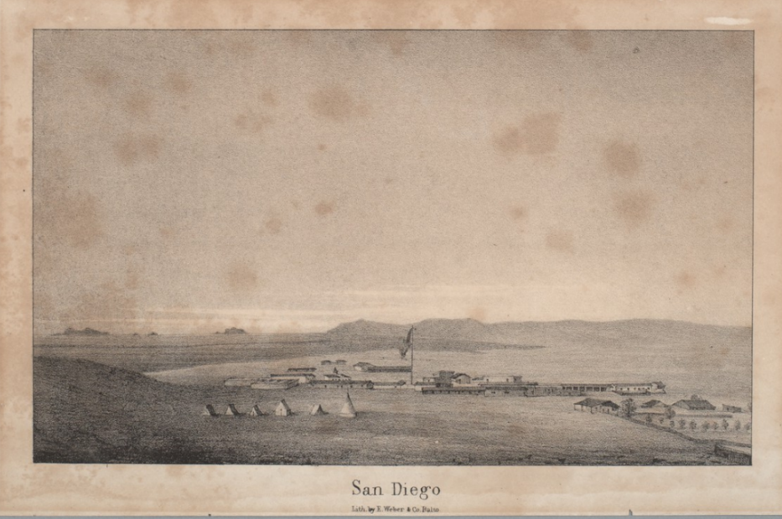
Military Lithograph of San Diego 1846

Lithograph

On the one hand, early colonizers, including topographical engineers, rank-and-file soldiers and military brass, real estate speculators, and would-be colonists – universally said that the region’s temperature was pretty great. Genial is the term they used, with the root of that word deriving from genea meaning of kin to their bodies, something comfortable. But, and here is the kicker, they also, just as frequently complained about the lack of necessary precipitation for colonization. In short, what was later called the perfect climate lacked some key climate requirements for colonization. What they concluded was that San Diego was a “barren” climate characterized by the type of shrunken semi-desert ecosystems that corresponds to all regions that lack rain. In terms of its ecology, it was knee high in most places, with only dwarfed trees and biota and none of the ecosystem services, like water or biofuels, or any of the necessary climate regulators, like trees for shade and lumber for shelter, that colonists believed were essential for making up a good climate that would allow them to live in the ways they intended. The local Kumeyaay had adapted a modest material culture suited to the scarcity and variability of rain.

But Anglo colonists set out to remake this climate for colonization through extreme infrastructural modifications and aggressive marketing schemes.

The US military and absentee capital were the key drivers in this process. They played the dominant role in water development, energy development, and in pushing the extreme ecological makeover of the region that turned the county into what people would later come to perceive and experience as a climate haven.

Once this sun was domesticated, marketers could capitalize on it, bottle it up, and sell it as ideal for colonial investment, colonial tourism, and colonial military training.
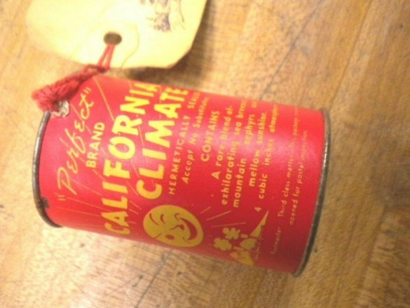

Today the mythology, widely shared both in official city propaganda and in local lore, is that this perfect climate produces on its own a laid-back Southern California disposition – “A Sunny Outlook… Fueled by Positive Vibes,” as this official city marketing brochure tells you.


2020 Tourist Authority
“Climate Always Great,” “A Sunny Outlook Fueled by Good Vibes”

Let me just pause to clarify how deeply steeped San Diego is in the history of US empire. It is despite its sunny and laid-back façade, a key node in the US military portfolio, a conservative military garrison with an economy that grew, especially after WWI and WWII, into a massive high-tech weapons hub on the backs of defense spending. Even today, 25% of its GDP derives from Department of Defense spending. And the imperial logic of this city is so deep that the funding structures of even its main climate science research institution, the Scripps Institution of Oceanography, derives 40% of its funding from the Department of Defense.
So how did colonial capital and the US military rebuild this climate to make it the world’s most perfect climate – from this colonial point of view.
They did that by importing into what was a sleepy Mexican ranching town enduring structures of militarism, market capitalism, technologism, scientism, and western aesthetics, that wholly transformed both how people looked and utilized this climate and how the composition of this climate expressed itself on the microlevel and macrolevels.
Two quick historical examples:
- First, water and climate:
You can’t have a good climate any by human reckoning without an adequate water supply. Precipitation is a key part of climate, and San Diego fails pretty handily for a colonization project on this ground. Without artificial interventions, it is a bad climate for building a megapolis of 3.3 million people and hosting the world’s largest urban military presence.
First private speculators, led by the Southern Pacific Railroad, and then later the US Navy brought water to the city to make colonization feasible. The details of this are not important, but suffice it to say that San Diego is an unconscionable water user with the wealthiest, greenest areas of the city consuming a disproportionate amount of that water.
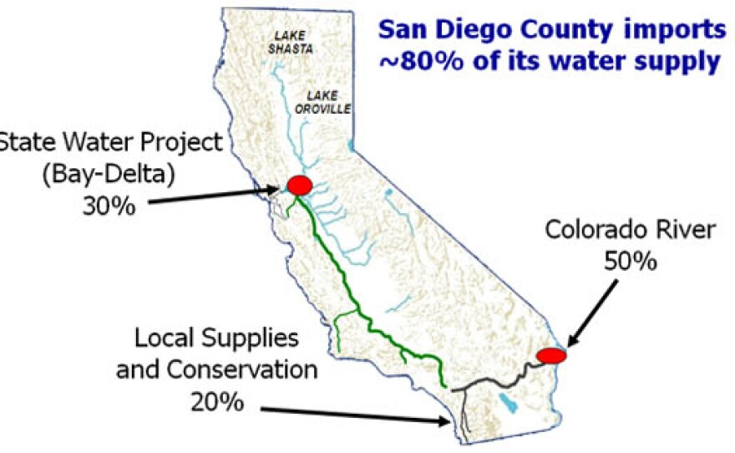
San Diego Imported Rain Map
Water, or we might think of it as artificial rain, made this climate level at the ground level. It allowed for the creation of lush green microclimates around the city with lowered ambient air temperatures by way of canopies of water-hungry eucalyptus groves and the fig, pepper, and hundreds of other varieties of trees imported to make up the city’s iconic central park. Tree canopies lower ambient air temperatures by as much as 10% when grouped sufficiently – and so the records of San Diego show millions of trees being planted as soon as water was brought in. 10,000 trees on so and so’s farm, 8,000 trees on so and so’s farm. These remade the atmosphere on the level of lived experience turning San Diego into what came to feel like a temperate or tropical climate much of the time – lush, green, more oxygenated, and protected from UV and other elements.
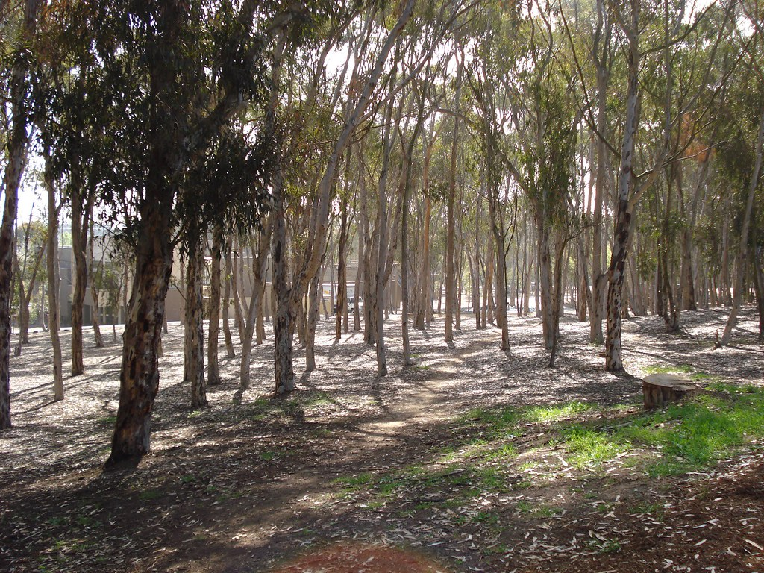
The Wet Microclimate: UCSD Eucalyptus Groves
The city’s iconic zoo and Balboa Park are perhaps the most lavish examples of this deep ecological colonization of San Diego once artificial rain was brought in.
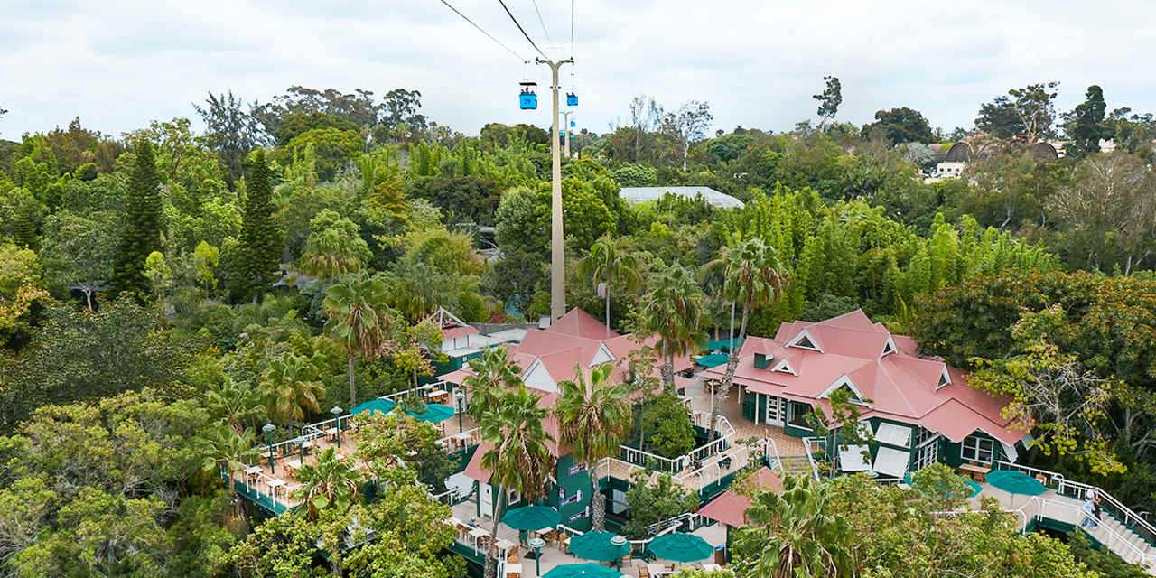
Lowering the Ambient Air Temperature
And this was one of the key achievements that colonists celebrated in their world fairs and in marketing brochures. In fact, the famous 1915 Pan American Exposition brochure is mostly made up of countless pages of plants brought in to green San Diego.

Image of Pan Am Brochure

The point here is not the old story of ecological colonization – that is, of merely changing the biota of a region through colonial activities but of actually changing the abiotic conditions of the atmosphere (temperature, humidity, and the like) – these parts of nature that we once that were aloof to human activity. Colonization altered the physical composition of the air and temperature wherever colonists showed up. And this was well before HVAC systems, climate-controlled automobiles, and the like – only further intensified how climate was geoengineered through colonial activities.

We don’t experience climate except through these colonial mediators – and thus to know a climate is to know the assemblages that enable the experience.

Of course, geoengineering a climate, even a microclimate, is risky business. And unintended consequences resulted as well modifying this climate in stranger ways.
The best example of an unintended modification of the climate traces back to the creation of the Salton Sea, California’s largest lake, in 1905, a lake accidentally created by human error in the Sonora Desert when man-made aqueducts used for irrigation broke down in 1905 to send the entire Colorado River, ten times the volume of the Thames river, the largest artery in the American West, into the desert. For nearly two years, the river ran into one of the lowest points in California, the Salton Basin, 269 feet below sea level, filling up that basin to create a saltwater lake. Suddenly in one of the driest deserts on earth, in what the World Meteorological Association, calls the sunniest place on earth – were boats and bathers showing up.
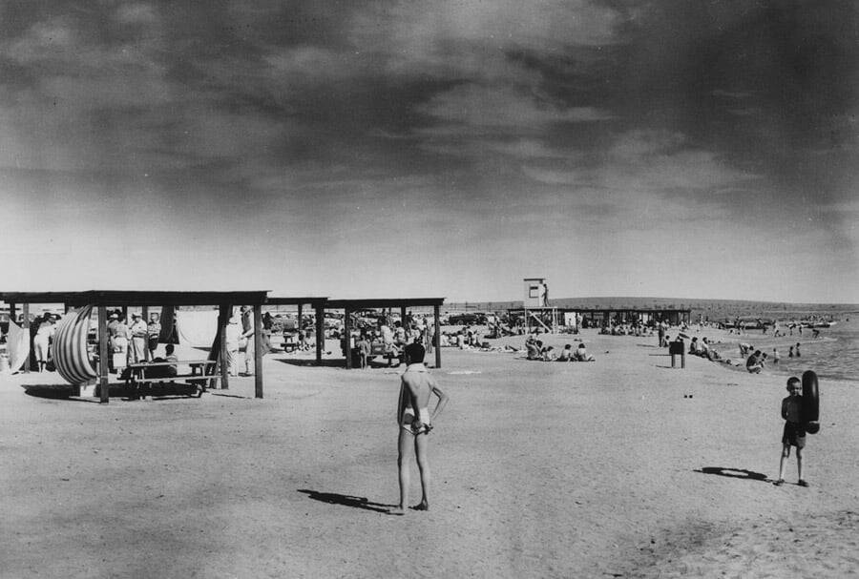
Swimming in the Desert with a Humidity Factor of 90%
What this meant for the climate is that local humidity shot up to 90 degrees in the summertime, making the desert feel like the Everglades, in this part of the Imperial Valley, or the valley of the empire. That humidity, a manmade product, only survives today because of ongoing colonial activities. The Imperial Valley was dreamed up as a colonial agricultural colony where farming could occur year round without regards to seasons – and thus it is today home to most of the fresh winter vegetables in the US and the run off from those farms keeps this lake and this humidity alive.
Second, energy and climate:
I want to close up this talk by moving to energy – the subject of this conference.
Energy, namely, oil, was, like water, at the root of the colonial climate in San Diego – the key to the production of livable microclimates but also the cause of unwanted blowback from colonial activities – climate change. It was again, in the case of San Diego, the US military that paved the way for scaling up of high-consumption energy practices in San Diego. We can see the same pattern as we do elsewhere -- some coal-fired steam ships first, then coal-fired railways, then electric trolleys, and a few cars, but San Diego was still, prior to the big military build up, a pretty small town of 100,000 people, making it a rather large village, until the city’s rebirth as a military metropolis during WWII as water and oil were brought in to turn it into a major high-tech defense economy, a massive megalopolis, and a high-energy sunbelt city characterized by long commutes by automobile and decentralized suburban housing with climate controlled interiors – the sort of stuff that makes up the post-WWII Great Acceleration that led to climate change.
San Diego has no coal, no oil, and very little biofuel.
All of this was imported by boat, by horse, and by rail to augment the dwarfed ecosystem services of the desert. That was until the post-WWII ramp up when the biggest landholders in the state, the Southern Pacific Railway, teamed up with the US Navy to build a 135-mile large diameter pipeline, the San Diego Pipeline, that ran from the oil refineries of Los Angeles to the military bases, dockyards, and consumer spaces of San Diego. That pipeline, the invisible infrastructure that this conference tries to render visible, came by midcentury to deliver jet fuel, diesel fuel, and gasoline at a a whopping 94,500 barrels a day. And this is just the initial pipe in San Diego’s tentacular energy infrastructure.
The San Diego Pipeline, and the larger energy culture it stands for, has allowed for the deep ecological colonization of San Diego, the demographic boom that followed, the pumping of the water that sustains this all, and the creation of a rising modern built environment of steel and concrete, ribbons of commuter highways, and HVAC systems that control the microclimate while producing climate change.
This is the stuff I’ve tried to document in my previous books.
- Third, energy consumption and the colonial climate;
Let me just point out quickly here the obvious: these fossilized infrastructures and the materially intensive practices of a high-water, high-energy, high-resource consumer culture have induced global warming – they have made the colonial climate a wild beast, a humanized product in which colonization has not only altered the microclimates of the region but has affect the entire atmospheric events that we call the macroclimate:
  - the rain is now human,
  - drought and flooding are something we have made,
  - the temperature has something to do with you and me,
  - the barometric pressure is yours and mine to claim,
  - the humidity is no longer something independent of human affairs,
  - and so on.

So we need a different way of talking about this. Is it the colonial climate that we inhabit? Does it have a beginning? And will it then also have an end as we transition to something else?

PART 7: WHAT DOES CLIMATE LOOK LIKE THROUGH THIS LENS?

So if we think we might want to name all of this the colonial climate, then things start to look a little different than they currently do.
Indulge me as we try to reread the cover of the 4th Regional IPCC Report in my home district of San Diego, this key document on climate change in the region. Every region in the US has one of these sub-reports on how climate change will affect its region. Here is the image in question:
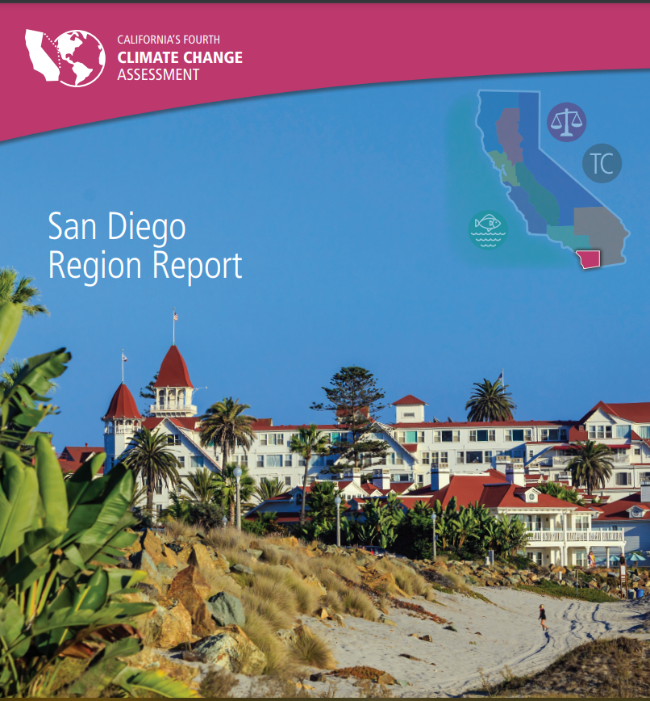
If we read this image, and the Climate Change report that accompanies it, as a story of climate change, as the report tells us to do, we see a certain type of historical narrative emerge. This is the prevailing dominant messaging:
- Humanity, symbolized by this vulnerable child, is under threat.
- The Hotel Del Coronado, this testament to modernity’s progress, and to the joys of the modern leisure society, is at risk of flooding, overheating, and so on.
- And it’s our job to do something to save this world of comfort we have built that expresses itself in clean lines of ivory paint, lush green palms rising skyward and banana trees squatting low.
- We all know the imperative: let’s get to work on saving civilization, saving the status quo.
But if we think of this report under the logic of the colonial climate, there is a subtle shift in the message:
- We see that we are being tasked with saving a certain colonial ordering of nature and society that might be problematic in and of itself:

  - We see that this symbol of civilization that is under threat is the low-lying Hotel Del Coronado, the first massive first-class leisure hotel in San Diego that was explicitly built as a colonial comfort station on the world circuit back in 1880 when San Diego was being marketed to Anglo investors and settlers as the world’s finest climate.

  - And as we focus our sympathies on this beautiful blonde girl, not like my own child, we might wonder a bit about how we chose to represent the bifurcations of white privilege and brown precarity, working class labor in this sun and bourgeois leisure – it makes us wonder a bit about what homes we are protecting and whose homes we are bent on protecting.
If we look inside the report, the main message, while only implicit, is that we have to protect this colonial ordering of nature and society by:
- Routing limited taxpayer dollars to arm the coasts where some of the wealthiest seaside homes are – and which are the symbol of this colonial legacy space as a settler society.
- Using federal funding to shore up the Naval Bases and Air Force bases located on San Diego Bay – and which are the symbol of the military conquest of this space that turned San Diego into the world’s largest urban defense cluster – where 25% of the county’s gross domestic product traces back to defense spending that drives the city as a high-tech hub.
And it might not surprise you that in this report most of the examples of civilization at risk focus on the coastal North County that is disproportionately white and privileged. The Hispanic parts of the city are mostly left to a few remarks here and there, the XXX
So might naming what we are wrestling with “the colonial climate” provide an optic that can better bear the weight of this history that we need to write?

PART 8: AQUAMAN AND THE END OF THE COLONIAL CLIMATE

So where does this leave us?
The Colonial Climate will not drown San Diego, only parts of its coastline. But it will heat up. It will return more and more to the desert. David Hockney lawns will continue to be torn up and replaced with xeriscaped, drought-resistant front and back yards.
Aquaman won’t be of much use to us when the desert reasserts itself and the colonial climate dries up. He won’t save this once lily white city that peaked at 70% white in 1970, that created the world’s perfect climate on the heals of dispossessing the Kumeyaay tribes, and that displaced those of Mexican descent who also used and claimed this space. There will be no sense in growing gills for the desert.
But he is right in warning us that “we can NEVER go HOME.” Home has been displaced. We have displaced it. The Colonial Climate is running its course. It is not done. And there are many people still deeply attached to it.
But maybe its end is an opportunity. Maybe it is time to imagine a postcolonial climate that aligns better to our values anyway.

Endnotes London School of Economics and Political Science, “High-income Countries Are Responsible for 74 Percent of Excess Resource Use,” April 6, 2022, https://www.lse.ac.uk/News/Latest-news-from-LSE/2022/d-Apr-22/High-income-countries-responsible-for-74-percent-of-excess-resource-use.

